UNIVERSITY LOGBOOK
BIT3208: Advanced Web Design and Development
K
a
m
a
t
h
i
'
s

K
i
t
c
h
e
n

S
t
o
r
e

—

S
m
a
r
t

E
-
C
o
m
m
e
r
c
e

W
e
b

A
p
p
l
i
c
a
t
i
o
n
Student Name
Vivian Kamathi
Registration Number
BBIT/2024/73472
Course
BBIT
Unit Code
BIT3208
Unit Name
Advanced Web Design and Development
Lecturer
Nyoro Michael
Semester / Year
Year 3, Semester 2
Project Title
Kamathi's Kitchen Store
Technology Stack
PHP + MySQL + HTML5 + CSS3 + JavaScript
GitHub Repository
https://github.com/[your-username]/kamathis-kitchen
Week 1: Local Environment Setup
Title: Installation and Testing of Local Development Environment
Required Evidence
Figure
Description
Evidence
Fig 1
Installation of XAMPP on Windows
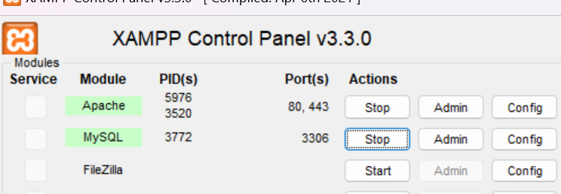

Fig 2
Apache and MySQL services running in XAMPP Control Panel


Fig 3
Localhost test page running in browser
Fig 4
First PHP Hello World page

Fig 5
Database connection test using mysqli
Screenshot of successful DB
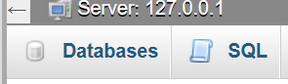
Student Re
fl
ection
During Week 1, I successfully installed and con
fi
gured XAMPP as my local development environment.
The installation process involved setting up Apache as the web server and MySQL as the database
engine. Fig 1 shows the successful XAMPP installation on my Windows machine. Fig 2 con
fi
rms that
both Apache and MySQL services are running correctly as indicated by the green status indicators in
the XAMPP Control Panel.
Fig 3 demonstrates that the localhost environment is functional and accessible through the browser. I
created my
fi
rst PHP script as shown in Fig 4, which con
fi
rmed that PHP was correctly con
fi
gured. Fig
5
shows a successful database connection test using PHP's mysqli_connect() function, con
fi
rming that
the database layer was properly set up.
The main challenge encountered was ensuring that port 80 was not blocked by other applications. This
was resolved by changing the Apache port con
fi
guration in the XAMPP settings.
Week 2: Wireframes and GUI Design
Title: User Interface Planning and System Design
Required Evidence
Figure
Description
Evidence
Fig 1
Hand-drawn wireframe of the Login page

Fig 2
Dashboard/Menu layout design


Fig 3
Mobile view mockup of menu page
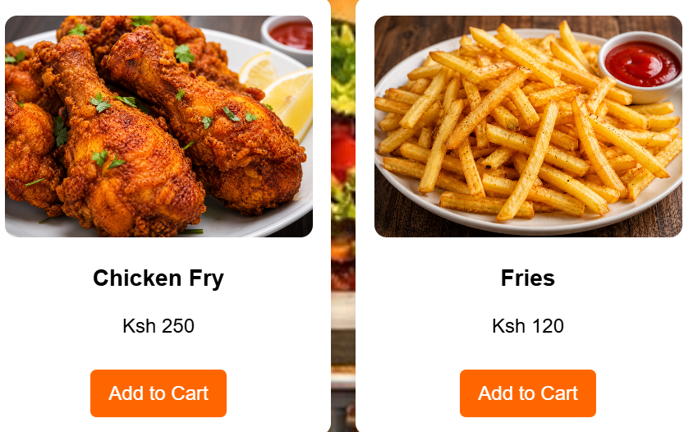

Fig 4
Color theme: Orange (#E65C00), Dark (#1A1A1A), White

Fig 5
GUI Prototype showing full navigation
fl
ow

Student Re
fl
ection
Week 2 focused on designing the user interface for Kamathi's Kitchen Store before writing any code.
The design process started with hand-drawn wireframes (Fig 1) to map out the login, registration, and
menu pages. This helped identify the navigation
fl
ow between pages early in the project.
The dashboard layout (Fig 2) was designed with a card-based grid system to display food items clearly.
A food photography background image was selected to create an immersive kitchen atmosphere. The
color theme (Fig 4) uses burnt orange (#E65C00) as the primary accent color to represent warmth and
food, complemented by a dark navbar for contrast and readability.
Fig 5 shows the full GUI prototype illustrating the complete navigation
fl
ow from login through menu,
cart, checkout, and back. The mobile-
fi
rst approach ensured the layout would be responsive across
devices.
Week 3: JavaScript, PHP and Authentication System
Title: Frontend Interaction and Backend Foundations
Required Evidence
Figure
Description
Evidence
Fig 1
Login form with PHP session management

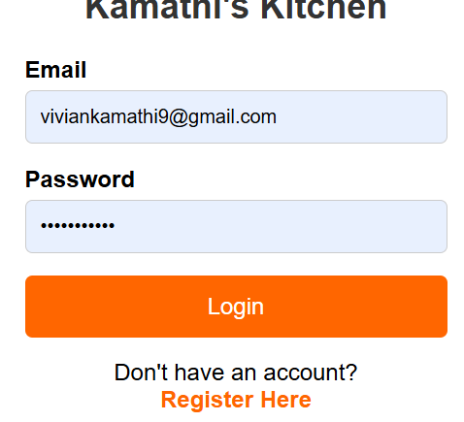
Fig 2
Registration form with server-side validation
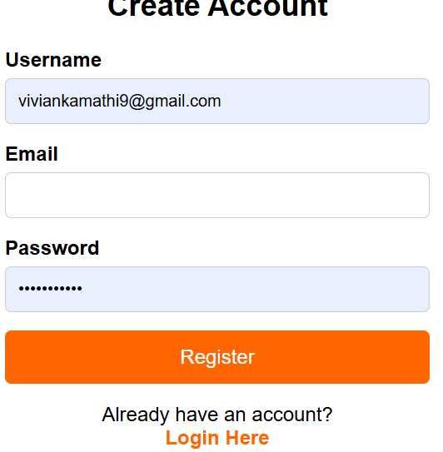
Fig 3
db.php database connection script

Fig 4
Session variables storing user_id and username

Fig 5
Menu page displaying Welcome [username] after login


Student Re
fl
ection
Week 3 involved building the authentication system for Kamathi's Kitchen Store using PHP and MySQL.
The login system (Fig 1) uses PHP session management to maintain user state across pages. When a
user logs in, their user_id and username are stored in $_SESSION variables as demonstrated in Fig 4,
allowing the menu page to display a personalized welcome message.
The registration form (Fig 2) includes server-side validation to ensure data integrity before insertion
into the database. The db.php connection script (Fig 3) uses PHP's mysqli extension to establish a
secure connection to the MySQL database. A key challenge was resolving a column name mismatch
between the database schema (name) and the PHP code (username), diagnosed using
var_dump($_SESSION) and corrected.
Fig 5 shows the successfully authenticated menu page displaying the logged-in user's name.
JavaScript was used for client-side form interaction while PHP handled all server-side processing and
database queries.
Week 4: Menu, Cart and Checkout System
Title: E-Commerce Core Functionality
Required Evidence
Figure
Description
Evidence
Fig 1
Menu page with product cards, images and prices


Fig 2
Add to Cart functionality storing items in session
Fig 3
Cart page listing items with total and Remove option


Fig 4
Checkout form with delivery details and order summary


Fig 5
Order Placed success screen showing Order #
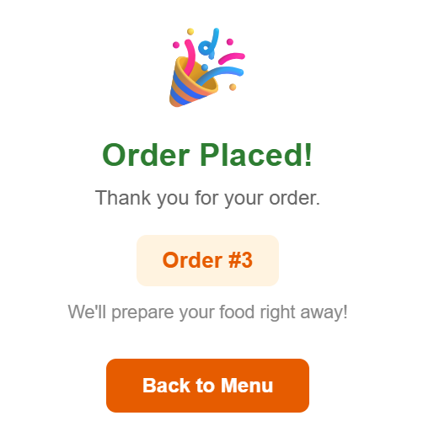

Student Re
fl
ection
Week 4 built the core e-commerce functionality. The menu page (Fig 1) dynamically fetches all
products from the MySQL database using a SELECT * FROM products query and displays them as
styled cards with images, names, prices, and Add to Cart buttons. Product images are stored in the
images/ folder and referenced by
fi
lename in the database.
The cart system (Fig 2 & 3) uses PHP session arrays to store cart items without requiring a database
write on every interaction. Each item is stored as an associative array containing the product id, name,
and price. The cart page loops through $_SESSION['cart'] to display all items and calculates the running
total.
The checkout system (Fig 4) collects delivery details. On form submission, the order is saved to the
orders table and each cart item to order_items, after which the session cart is cleared. Fig 5 shows the
success con
fi
rmation screen displaying the unique Order ID.
Week 5: Admin Panel and System Testing
Title: Administration Dashboard and Full System Testing
Required Evidence
Figure
Description
Evidence
Fig 1
Admin dashboard showing orders table with stats
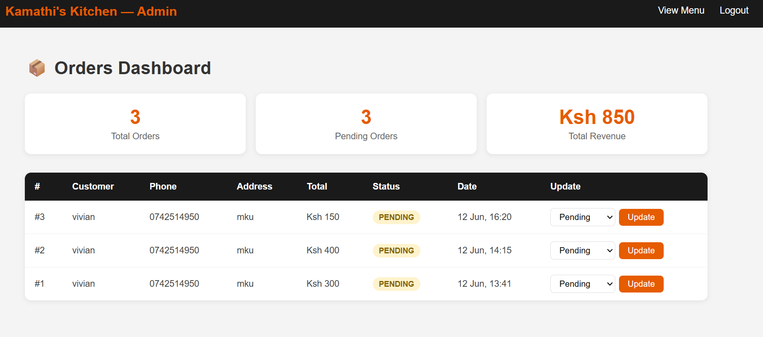

Fig 2
Order status update from Pending to Con
fi
rmed
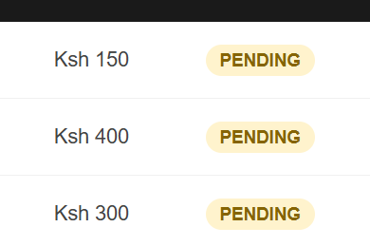
Fig 3
Database tables in phpMyAdmin
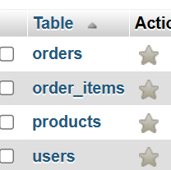
Fig 4
Navbar with Menu, Cart and Logout links


Fig 5
Full system
fl
ow: Login to Order Placed
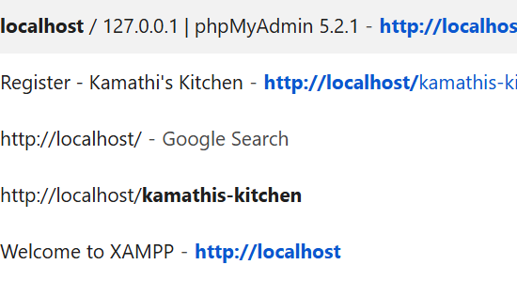
Student Re
fl
ection
Week 5 completed the admin panel and full system testing. The admin dashboard (Fig 1) provides a
real-time overview including total orders, pending orders, and total revenue. All orders are displayed in a
structured table with customer name, phone, address, total amount, status, and timestamp.
The order status management feature (Fig 2) allows the admin to update order status through a
dropdown with six options: Pending, Con
fi
rmed, Preparing, Ready, Delivered, and Cancelled. Fig 3
shows the complete database schema in phpMyAdmin with all four tables properly structured and
populated with real order data.
Full system testing (Fig 5) con
fi
rmed that all user journeys work correctly: a new user can register, log
in, browse the menu, add items to cart, checkout, and the order appears in the admin panel. The
system meets all baseline requirements speci
fi
ed in the project brief.
Project Summary
System Features Completed
User Registration and Login with PHP session management
Role-based access (admin and customer)
Product catalog with images, names, and prices
Shopping cart using PHP session arrays
Checkout system with delivery details collection
Order management saved to MySQL database
Admin dashboard with order status management
Responsive navbar with logout functionality
Background image and styled UI throughout
Technologies Used
Frontend: HTML5, CSS3, JavaScript
Backend: PHP 8.x
Database: MySQL via phpMyAdmin
Server: Apache (XAMPP)
Editor: Visual Studio Code
Version Control: Git / GitHub
Challenges and Solutions
Challenge
Solution
Unde
fi
ned array key 'username'
warning
Fixed by matching DB column name (name) with session key
assignment in login.php
Product images not displaying
Updated image column in products table with correct
fi
lenames
matching images/ folder
Incorrect password error on login
Fixed INSERT column mismatch (username vs name) in register.php
and re-registered fresh account
Headings not visible over
background image
Added color:#fff and text-shadow CSS properties to h1 and h2
elements
Duplicate DOCTYPE in menu.php
Removed the duplicate HTML structure that was causing rendering
issues

